**TRƯỜNG THCS PHAN CÔNG HỚN**

**TỔ TIẾNG ANH**

**TIẾNG ANH 8**

**TUẦN 28 (TỪ 24/03 ĐẾN 29/03)**

**SỬA BÀI TUẦN 27**

**Period 79, 80, 81**

**REVISION FOR THE MIDTERM TEST**

**TEST 1**

***I. Listen to the record player three times, then choose the best answer (A, B, C or D). (1pt)***

**1.**

**2.**

**3.**

**4.**

**ANSWERS**

***CD1 – TRACK 61***

1. What did Sofia want Jack to help her choose?

**A. a smartphone** B. a laptop C. a tablet D. a computer

2. Which part of Nebula Z isn’t good?

A. storage B. speaker **C. screen** D. battery

3. How long can the battery last?

A. 2 hours B. 12 hours C. a day **D. 2 days**

4. Is Nebula Z expensive?

A. Yes, it is **B. No, it isn’t** C. Yes, it does D. No, it doesn’t

***II. Choose the word or phrase (A, B, C or D) that best fits the space or best answers the question given in each sentence. (2.5 pts)***

**5.**

**6.**

**7.**

**8.**

**9.**

**10.**

**11.**

**12.**

**13.**

**14.**

**ANSWERS**

**5.** Which word has the underlined part pronounced differently from that of the others?

A. b**a**ttery B. l**a**ptop **C. storage** D. r**a**m

**6.** Which word has the underlined part pronounced differently from that of the others?

A. travel**ed** B. open**ed** C. learn**ed** **D. passed**

**7.** Which word has a different stress pattern from that of the others?

**A. navigation** B. recognize C. audience D. gigabyte

**8.** Which word has a different stress pattern from that of the others?

A. oxygen **B. volunteer** C. gravity D. hospital

**9.** We’ve had to build some cupboards in the kitchen to give us more _______ space.

A. digital **B. device** C. bigger D. storage

**10.** The _______ can fall below zero degrees Celsius in Winter.

A. gravity B. space station **C. temperature** D. Venus

**11.** I need two more vases to _______ the collection.

A. charge B. lift **C. complete** D. rescue

**12.** The atmosphere on Mars is quite similar _______   that on Earth.

A. on B. at **C. to** D. with

**13.** _______ do you use your laptop for?

A. How **B. What** C. How much D. Are

**14.** Although Lucy is cheaper than Andy, she can complete the tasks _______  than him.

**A. more quietly** B. quietly C. quietlier D. more quiet

***II. Look at the signs. Choose the best answer (A, B, C or D) for questions 15 and 16. (0.5pt)***

***(Từ câu 15 đến câu 16, thí sinh chỉ viết mẫu tự (A, B, C hoặc D) đại diện cho câu trả lời đúng vào Phần ANSWERS)***

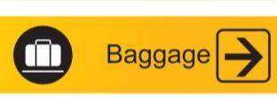**15.** What does the sign mean?

**ANSWERS**

**16.**

**15.**

1. Put your baggage here before check-in.
2. **Get your baggage after landing this way.**

C. Buy a suitcase here.

D. Take your suitcase here to get on board.

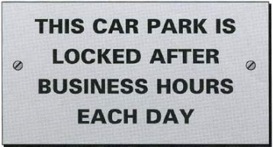**16.** What does the sign mean?

A. Users must lock the car park after leaving

**B. People can park here while they are at work**

C. This car park is for employees only.

D. You can park here at the weekends.

***III.* *Choose the word (A, B, C or D) that best fits the space in the following passage. (1.5 pts)***

 Indeed, Gary wasn’t (17) _______to play your favorite tunes on demand or to (18) _______ a video call to your grandkids. Instead, Gary could remove dirty towels from the laundry basket and put them in the washer (great for the gym or at home). He can (19) _______ the plants, load the dishwasher and open jars. In a restaurant, he could (20) _______ food or greet customers at the door. In a hotel, he could strip the bedsheets or refill the shampoo and conditioner.

**17.**

**18.**

**ANSWERS**

**19.**

**20.**

**21.**

**22.**

Gary can carry up to 11 pounds in his two (21) _______ arms (although he hasn’t quite mastered the art of folding clothes, Altagar admits). His sensors and (22) _______ include one to take a 3D view of a room and a camera to see in the dark.

**17.** A.included B. worked **C. designed** D. told

**18.** A. connect B. do **C. make** D. hang up

**19. A. water** B. make C. cut D. climb

**20.** A. smell **B. serve** C. fell D. create

**21.** A. glassware **B. robot** C. robotic D. crystal

**22.** A. body B. program **C. camera** D. designing

***IV*. *Read the following passage. Decide if the statements from 23 to 26 are True or False and choose the correct answer (A, B, C or D) for the questions 27 and 28*. *(1.5 pts)***

An unidentified flying object, or UFO, is anything in the sky that the person who sees it cannot explain. Some people believe UFOs are alien spacecraft. However, most scientists believe that it can be easier to explain UFOs. A UFO has different descriptions. It can take the form of a disk, triangle or even an egg. After a sighting of a disk-shaped UFO in the 1940s, the term “flying saucer” became popular. It soon became of fashionable to call all UFOs flying saucers. Nowadays, there are records of thousands of UFO sighting. There are photographs of UFOs and conversations with the people who saw UFOs. In the 1950s, a government asked a group of scientists to study hundreds of sightings. However, most sightings were just space objects like stars, planets or meteors. A lot of other sightings were only aircraft, birds or hot gases. However, such things didn’t stop people from reporting UFOs. By the mid-1960s, there were even more sightings of UFOs than ever. People also found that most UFO are alien sightings happened in bad weather. But governments around the world still believed that UFOs were unreal. Other scientists agreed. But it was hard to explain why UFOs still appeared. Nowadays, researchers believe that UFOs might be visitors from space.

**23.**

**24.**

**25.**

**26.**

**27.**

**28.**

**ANWERS**

**23.** It is easy for a person to describe a UFO when he or she sees it. **FALSE**

**24.** Most researchers believe that explaining UFOs will be easier. **TRUE**

**25.** A UFO can be a disk-shaped or egg-shaped object. **TRUE**

**26.** The term “flying saucer” was popular in 1940s. **TRUE**

**27.** When did the researchers start to study UFO sightings?

A. In the 1940s **B. In the 1950s** C. In the mid-1960s D. In the 1960s

**28.** In what kind of weather did UFOs or aliens often appear?

**A. bad weather** B. good weather C. rainy D. sunny

***V. Use the correct form of the word given in each sentence. ( 1.5 pts)***

**29.** Make a smart choice, you will have a much ____**BRIGHTER**___ future ahead. (bright)

**30.** They were _____**TERRIFIED**_____of what they saw in the mountains. (terrify)

**31.** The latest tablet can _____**PERFORM**______ many tabs at one time. (performance)

**32.** After a while, an alien-shape creature______**DISAPPEARED**______without a trace. (appearance)

**33.** The ____**POWERFUL**___ battery allows this phone to be able to work up to 72 hours. (power)

**34.** He was finishing in the lake when he saw a ____**CIRCULAR**___ object over the mountains. (circle)

**29.**______________ **30.**______________ **31.**______________

**ANSWERS**

**32.**______________  **33.**______________  **34.**______________

***VI. Look at the entry of the word “diappear” in a dictionary. Use what you can get from the entry to complete the sentences with two or three words (0.5pt)***

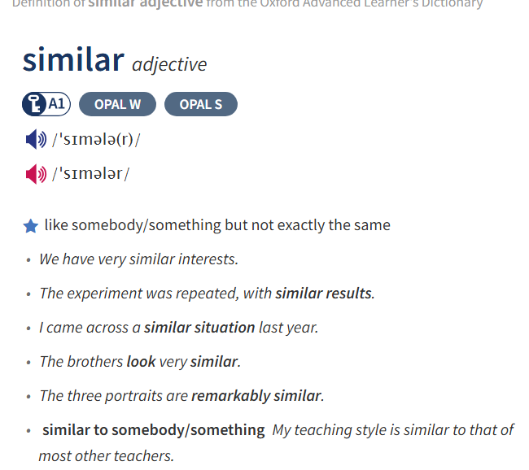

**35.** I believe that we are now in a __________**similar situation**_______. We should work together instead of complaining continously.

**36.** I bought some new shoes which are very _________**similar to**_______ a pair I had before.

***VII. Rewrite each of the following sentences in another way so that it means almost the same as the* *sentence printed before it. (1.0pt)***

**37.** Andy’s battery life lasts longer than Eddie’s.

**🡪 Eddie’s battery life** lasts shorter than Andy’s.

**38.** Tuan wants to reduce air pollution so he planted more trees last week.

**🡪 Because** Tuan wants to reduce air pollution, he planted more trees last week.

**39.** How much are these vacuums?

**🡪 How much** do these vacuums cost?

**40.** Mars’ gravity isn’t similar to Earth’s.

**🡪 Mars’** gravity is different from Earth’s.

**THE END OF THE TEST**

**TEST 2**

**ANSWERS**

***I. Listen to the record player three times, then choose the best answer (A, B, C or D). (1pt) CD2-07***

1. What was Nancy doing when she saw a UFO in her garden?

A. walking **B. reading** C. sleeping D. knitting

2. What does Nancy think it was?

A. an airplane B. a dish **C. a flying saucer** D. a planet

3. What did Jim do after he saw two strange people in the park?

**A. ran away** B. smiled at them C. talked to them D. screamed

4. Who does Jim think they were?

A. thieves B. tourists C. celebrities **D. aliens**

***I. Choose the word or phrase (A, B, C or D) that best fits the space or best answers the question given in each sentence. (3.5 pts)***

***(Từ câu 1 đến câu 14, thí sinh chỉ viết mẫu tự (A, B, C hoặc D) đại diện cho câu trả lời đúng vào Phần ANSWERS)***

**5.** Which word has the underlined part pronounced differently from that of the others?

A. t**a**blet B. d**a**ta C. b**a**ttery D. c**a**mera

**5.**

**6.**

**7.**

**8.**

**9.**

**10.**

**11.**

**12.**

**13.**

**14.**

**ANSWERS**

**6.** Which word has the underlined part pronounced differently from that of the others?

A. reach**ed** B. shap**ed** C. appear**ed**  D. talk**ed**

**7.** Which word has a different stress pattern from that of the others?

A. disappear B. circular C. temperature D. suddenly

**8.** Which word has a different stress pattern from that of the others?

A. terrified B. description C. recognize D. gravity

**9.** This smart phone has a great _______. You can easily read news, watch videos or play online

games with it.

A. storage B. camera C. screen D. chip

**10.** After a disaster, robots can help find people because they can _______ through dangerous

situations when human can’t.

A. lift B. recognize C. navigate D. rescue

**11.** Ho Chi Minh city is more and more _______ because many people came here for work

or studying.

A. big B. crowded C. excited D. safe

**12.** It’ll be very dangerous for the astronauts to stay for a long time on the moon because there is

no _______ for them to breath.

A. gravity B. temperature C. oxygen D. water

**13.** The scientists found a strange vehicle in the ocean. They think it’s a(n) _______ .

A. space station B. alien C. flying saucer D. UFO

**14.** ______________ is the battery life? – “It lasts 12 hours.”

A. How many B. How long C. How much D. How deep

***II. Look at the signs. Choose the best answer (A, B, C or D) for questions 15 and 16. (0.5pt)***

**ANSWERS**

**16.**

**15.**

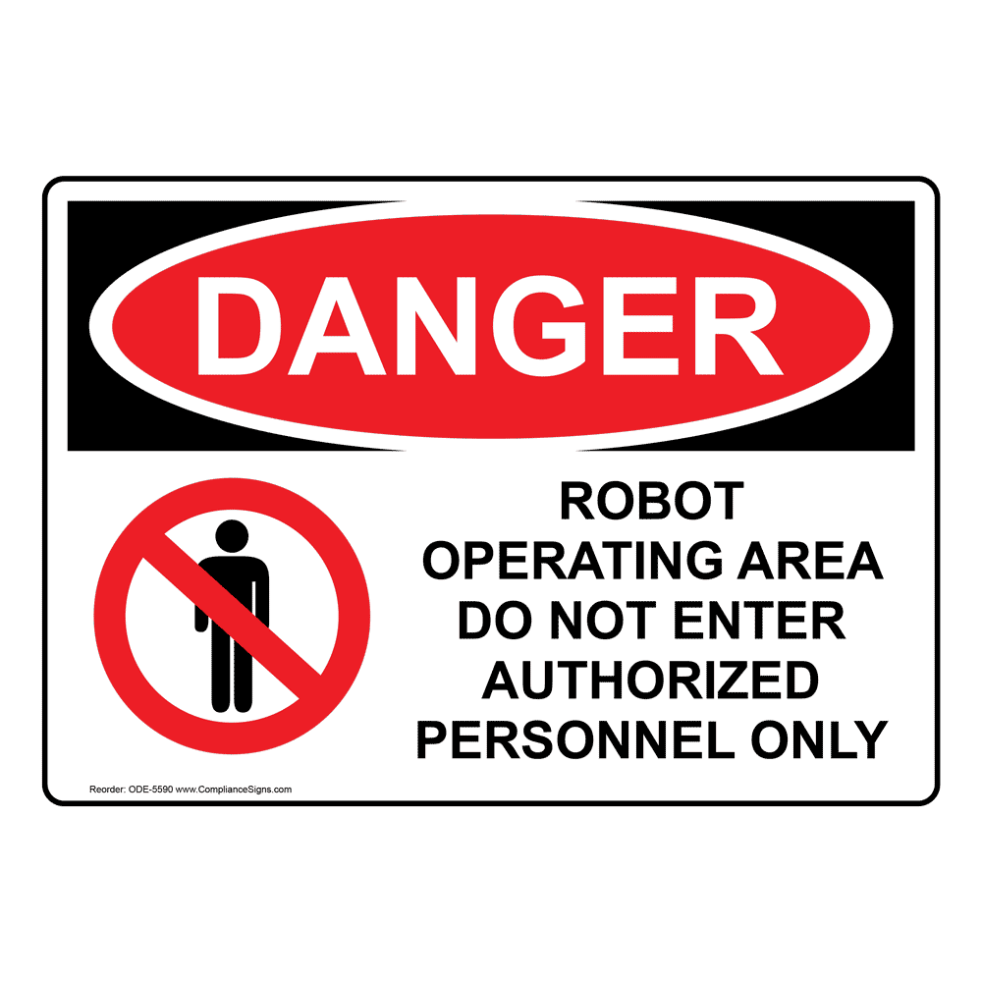**15.** When you see this sign, you should ________.

1. keep away from this area. C. enter with another person only.
2. not enter this area. D. A and B are correct.

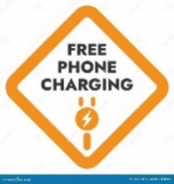**16.** When you see this sign, you can ________.

A. charge your phone here for free.

B. get a phone charger for free.

C. freely use the phone charger here.

D. have someone charge your phone freely.

***III.* *Choose the word (A, B, C or D) that best fits the space in the following passage. (1.5 pts)***

**17.**

**18.**

**ANSWERS**

**19.**

**20.**

**21.**

**22.**

Last week, Dinamycs introduced its new laptop, the XLAP 5. Is it better than the XLAP 4? Let’s see. The screen is 14 inches, and images are much brighter and clearer. I think this laptop is perfect for (17) _______ games. The XLAP 4 also has a good (18) _______, but it’s only 12 inches. The battery life of the XLAP 4 is really good. You can use it for 10 hours on a full (19) _______. However, the XLAP 5 only (20) _______ 8 hours. It’s stl better than most laptops. The storage on the XLAP 5 is good. It has 256 GB, (21) _______ the XLAP 4 only has 128 GB. The XLAP 5 is great if you want to have clear photos and videos and lots of games. The performance of the XLAP 5 is much better than the XLAP 4. It can do everything faster. That’s why (22) _______ battery life is a bit shorter than the XLAP 4’s. The XLAP 4 is now 500 dollars and the XLAP 5 is 750 dollars.

**17.** A. plays                          B. playing                        C. play                          D. played

**18.** A. storage                      B. battery                            C. screen                             D. speaker

**19.** A. lift                              B. complete                        C. charge                            D. circle

**20.** A. lasts                         B. has                                 C. is                                    D. works

**21.** A. so                               B. but                                  C. also                                 D. however

**22.** A. their                           B. this                                C. that                                D. its

***IV*. *Read the following passage. Decide if the statements from 23 to 26 are True or False and choose the correct answer (A, B, C or D) for the questions 27 and 28*. *(1.5 pts)***

**23.**

**24.**

**25.**

**26.**

**27.**

**28.**

**ANWERS**

Earth’s population is growing more quickly every year. I think that someday in the future, we will need to leave Earth and travel to new planets. I think that the best options are two planets near us in space, Mars and Venus. But which one will we travel to first?

Mars is often called “the Red Planet” because of its color. It is further from the sun than Earth, so it’s very cold. It is much smaller than Earth, so the gravity there is very low and there isn’t much oxygen, too. It will cause health problem for humans living there for a long time.

Venus is often called Earth’s “sister planet”. The two planets are almost the same size, so the gravity is very similar to Earth’s. However, Venus’s temperature is very hot, and the air is dangerous.

In my opinion, both planets are dangerous. However, travelling to Venus is more dangerous and difficult. I think that we will visit Mars first. I hope that we will learn more about other planets later, too.

**23.** The growth of Earth’s population is the reason why people need to move to another planet. TRUE

**24.** Mars and Venus are the best options because they are near us. TRUE

**25.** Mars is far from the Earth so it’s very cold. FALSE

**26.** Venus’s gravity is not different from Earth’s. FALSE

**27.** Venus is often _____________ as Earth’s “sister planet”

A. called B. named C. known D. remembered

**28.** According to the writer, we will visit Mars first because it’s ___________ than Venus.

A. safer B. more safe C. dangerous D.more dangerous

***V. Use the correct form of the word given in each sentence. ( 1.5 pts)***

**29.** It ___suddenly_ started to rain when Linda walked home after school. (sudden)

**30.** Last night, a UFO hovered above Jim’s house and then it quickly ____disappeared___. (appearance)

**31.** Mike saw two ___strangers__ climbed to second floor of his neighbor apartment yesterday. (strange)

**32.** Remember to bring an umbrella if you go ___outside__ these days. (inside)

**33.** In 2023, Tokyo is the most __crowded___ city in the world with more than 37 million people. (crowd)

**34.** She ___carefully___ cleaned the glass cups in order not to break any of them. (care)

**29.**______________ **30.**______________ **31.**______________

**ANSWERS**

**32.**______________  **33.**______________  **34.**______________

***VI. Look at the entry of the word “population” in a dictionary. Use what you can get from the entry to complete the sentences with two or three words (0.5pt) (0.5pt)***

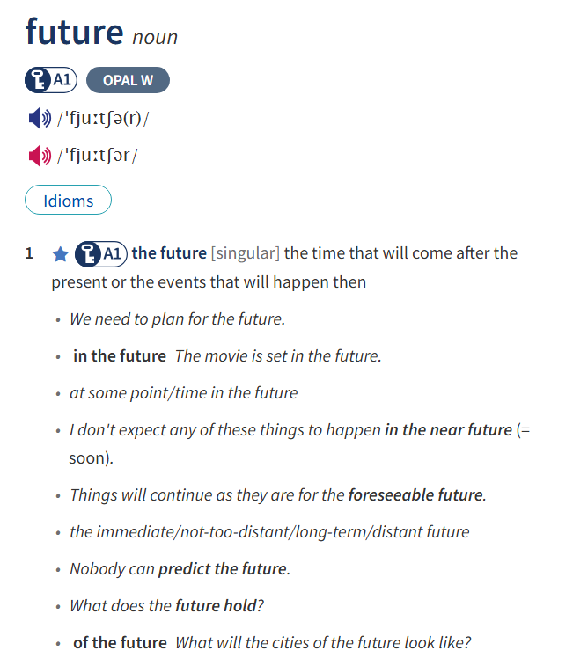

***35.*** Experts say oil prices will stay low for the _____foreseeable future______.

***36.*** You don't know what the ______future holds______, so make the most of every moment.

***VII. Rewrite each of the following sentences in another way so that it means almost the same as the* *sentence printed before it. (1.0pt)***

***(Từ câu 37 đến câu 40, thí sinh hoàn thành phần trả lời bên dưới mỗi câu)***

**37.** How heavy is that robot cleaner?

**🡪 What’s** the weight of that robot cleaner?

**38.** While we were having a barbecue in our garden, we saw some humanlike creatures.

**🡪 When we** saw some humanlike creatures, we were having a barbecue in our garden.

**39.** My phone has long battery life, but it is quite cheap.

**🡪 My phone** has long battery life although it is quite cheap.

**40.** Stumpy can recognize voices worse than Wall-D.

**🡪 Wall-D can** recognize voices better than Stumpy.

**THE END OF THE TEST**